**ASSIGNMENT 2**

**Team ID :** PNT2022TMID19314

**Name :** ABISHEK G

**Assignment:** Build a python code. Assume u get temperature and humidity values and write a condition to continuously detect alarm in case of high temperature **Date:**28-09-2022

**CODE**: import random while(True):

temp=random.randint(10,99) humid=random.randint(10,99)

print("current temperature:",temp) print("current humidity:",humid,"%") temp_ref=37 humid_ref=35 if temp>temp_ref and humid<humid_ref: print("Sound Alarm")

else:

print("Sound off") break

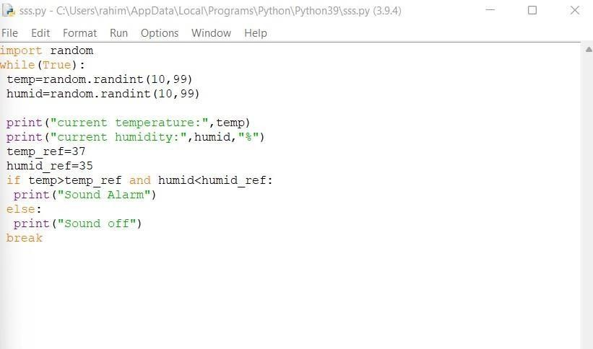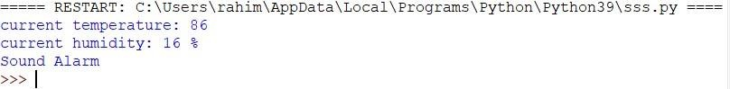

**PROGRAME:**

**Output :**